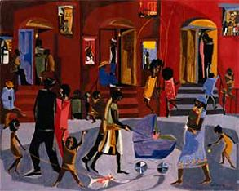

Access the Internet to answer questions for each section relating to the Harlem Renaissance. The websites have been provided. You must write in complete sentences for full credit.

- Jim Crow Laws
- http://www.ferris.edu/jimcrow/what.htm

- What are Jim Crow laws?
- Give an example of one of these laws.
- Access the Video Clip on YouTube-Jim Crow Laws. Write three facts from the video.

- The Causes of the Harlem Renaissance
- http://www.britannica.com/EBchecked/topic/255397/Harlem-Renaissance
- http://artsedge.kennedy-center.org/interactives/harlem/index.html
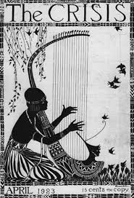
- Define Harlem Renaissance.

For question 5, access the Artsedge.Kennedy-Center. Click on Themes & Variations-Black Writers Tell it on the Mountain

- In at least two sentences, explain how each person or group contributed to the emergence of the Harlem Renaissance.

  - W.E.B. DuBois

  - Countee Cullen:

  - The Talented Tenth

- In your opinion, in what ways did the Harlem Renaissance help to bring about the Civil Rights Movement?

- The Great Migration
http://webpath.follettsoftware.com/resource/viewurl?encodedUrl=ytShbPhXhHaaSxITA330TTClA-q4izC88qA66kaRaqo&version=1&appsignature=Destiny&appversion=10.5.6.0+%28RC6%29
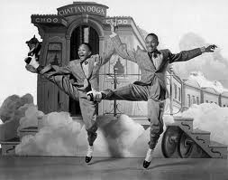
- Why did many African Americans migrate from the rural south to the Northern cities?
- Why was Harlem, a city in New York, the center of the African American literary movement and increasing population?

- Harlem Renaissance Artwork
http://webpath.follettsoftware.com/resource/viewurl?encodedUrl=plo2j1Ikxcj5uQozTp-kxVjIm5jHd3HIZd8w1IGywCs&version=1&appsignature=Destiny&appversion=10.5.6.0+%28RC6%29

Choose two artworks shown. Explain what is being depicted and how the picture reflects the Harlem Renaissance Movement.
- Artwork #1-
- Artwork #2-

- Harlem Renaissance Video & Audio Clips
http://artsedge.kennedy-center.org/interactives/harlem/index.html

Choose one Video and one Audio clip. Give the name and explain the subject matter in detail.
- Video Clip-
- Audio Clip-
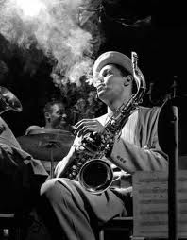
If you have finished your Harlem Renaissance Web Quest early, please peruse the websites listed and read the material to learn more about the Harlem Renaissance Movement and the individuals who took part in this awesome artistic birth of African American Art!

